Tools of Learning Reference Sheet
7th Grade Humanities

CONTENT IMPERATIVE ICONS
Name | Icon | Prompts | Definition
Origin |  | How did this get started?  What caused this?  Where did this begin?  What caused it to begin? | Students trace the beginning of the concept, skill, or idea they are studying.
Paradox |  | What are the things opposing each other?  What are the inconsistencies?  What is the dilemma? | Students identify statements or propositions that seem self-contradictory or absurd but in reality express possible truths.
Parallels |  | What is similar?  What is comparable?  What seems the same as? | Students find and explain commonalities between two or more entities.
Contributions |  | What is the value of this?  Who made contributions to this?  What factors or events helped make it what it is? | Students identify the contributions of particular individuals, other sources, or events to a subject of study or incident.
Convergence | 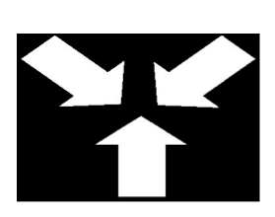 | What things came together to cause this?  What were the meeting points?  How did everything merge? | Students cite a convergence of ideas or events leading to a particular incident or effect.
Impact | 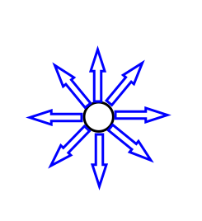 | What were the consequences?  Where might it go from here?  What were the effects? | Students determine the results of an event or concept.

DEPTH & COMPLEXITY ICONS
Name | Icon | Prompts | Examples
Language of the Discipline |  | What terms or words are specific to the work of the disciplinarian? What tools does the disciplinarian use? | Tools, jargon, slang, acronyms, special phrases, terms, abbreviations
Details |  | What are its attributes?  What features characterize this?  What distinguishes this from other things? Find examples and evidence to support opinions & ideas. | Parts, factors, attributes, variables, distinguishing traits
Patterns | 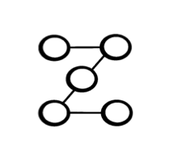 | What are the recurring events?  What elements events, ideas are repeated over time? What was the order of events? Make predictions on what will come next. | Repetition, predictability, cycles, recurring events, repeated features, things you KNOW will happen again
Trends | 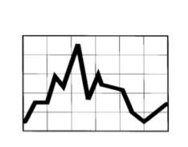 | Note factors that cause events to occur. Identify patterns of change over time. | Influences, forces, course of direction, fads, things that happen over and over again but in an UNPREDICTIBLE way
Unanswered Questions |  | What is still not understood about this area/ topic/ study/ discipline? What is yet unknown about this area/ topic/ study/ discipline? In what ways is the information incomplete or lacking in explanation? | Discrepancies, missing parts, unclear ideas, incomplete ideas, yet unknown, lacking in explanation
Rules | 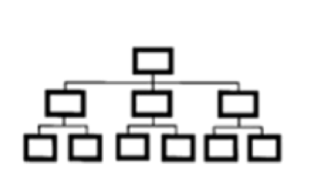 | How is it structured?  What guidelines govern it?  How is it a hierarchy or in order? | Structure, order, explanation, organization, laws
Ethics |  | What dilemmas or controversies are involved in this area/ topic/ study/ discipline? What elements can be identified that reflect bias, prejudice, discrimination? | Different opinions, points of view, judging, bias, controversial issues, problems, morals, prejudice, discrimination
Big Idea | 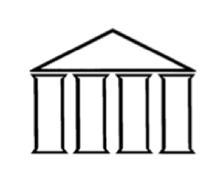 | What overarching statement best describes what is being studied? What general statement includes what is being studied? | Overarching ideas, broad idea that can be supported with evidence, generalization, universal concept to connect all learning
Relates Over Time |  | How do things change in the past, present, and future? Why doesn't everything change? How has time affected the information? | Looking at past, present and future relationships within a time period, applying from the past to the present
Multiple Perspectives | 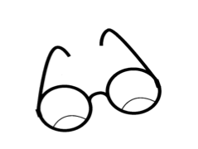 | What are the opposing viewpoints? How do different people and characters see this event or situation? | Different points of view, ways of seeing and reporting things, opposing viewpoints, outlooks, interpretations
Across the Disciplines | 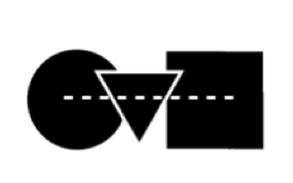 | How does this study connect across disciplines (SUBJECTS)? How is the relationship between this study and other disciplines evident? | Connections among disciplines , touching on many subjects at once, relationships within and between the disciplines

